Prior Knowledge Review

- State the definition of:
  - A force
____________________________________________________________________
____________________________________________________________________
  - Balanced forces
____________________________________________________________________
____________________________________________________________________
  - Resultant force
____________________________________________________________________
____________________________________________________________________
  - Contact force
____________________________________________________________________
____________________________________________________________________
  - Non-contact force
____________________________________________________________________
____________________________________________________________________
  - Friction
____________________________________________________________________
____________________________________________________________________
  - Mass
____________________________________________________________________
____________________________________________________________________
  - Weight
____________________________________________________________________
____________________________________________________________________

- State whether the following pairs of forces are balanced or unbalanced and calculate the resultant force in each case:
15 N
5 N

35 N
20 N

5 N
5 N

35 N
100 N

- Objects have different weights in different parts of the solar system.
  - State the equation used to calculate weight.

  - Complete the following table to show the masses and weights of objects in different parts of the solar system:

Take the gravitational field strength of the Moon as 1.6 N/kg.

Mass | Weight on Earth | Weight on the Moon
50 kg
 | 800 N
 |  | 48 N

  - State the definition of speed.
____________________________________________________________________
____________________________________________________________________

  - State the equation used to calculate speed with the SI units for each quantity.

  - Calculate the speed of a person who runs a 200 m race in 25 seconds.

  - Calculate how long it takes a car to drive 1000 m at 20 m/s.

  - Calculate how far a cyclist can travel in 1 minute at 15 m/s.

  - Calculate how fast an aeroplane is travelling if it covers 3 km in 12 seconds.

- Use the following distance-time graph to answer the questions below:
B
C
D
E
F
G
A
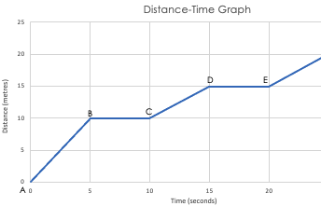
  - Between which points in the graph is the object stationary?

  - Between which points in the graph does the object have the greatest speed?

  - Describe the motion during each stage of this journey
    - A-B

    - B-C

    - C-D

    - D-E

    - E-F

